**LAB ACTIVITY**

**PENGOLAHAN CITRA DIGITAL**

**Pertemuan 2 – Load Image**

|  |  |
| --- | --- |
| Nama: Muhammad Rifqi Amir Putra | NPM: 062230701416 |
| Kelas: 5 CA | Mata Kuliah: Pengolahan Citra Digital |

**Alat dan Bahan:**

1. Text Editor
2. Python
3. Library Python OpenCV
4. Google Colab (Opsional)
5. Gambar
6. **Load Image menggunakan Python di Text Editor**

Source Code:

**import cv2 as cv**

**img = cv.imread('Gambar/gambar-kucing.jpg', 1)**

**dimensi =  img.shape**

**tinggi = img.shape[0]**

**lebar = img.shape[1]**

**channels = img.shape[2]**

**print('Dimensi gambar: ', dimensi)**

**print('Tinggi gambar: ', tinggi)**

**print('Lebar gambar: ', lebar)**

**print('Channel gambar: ', channels)**

**cv.imshow('Muhammad Rifqi Amir Putra - 5 CA', img)**

**print(img)**

**cv.waitKey(0)**

**cv.destroyAllWindows()**

Hasil:

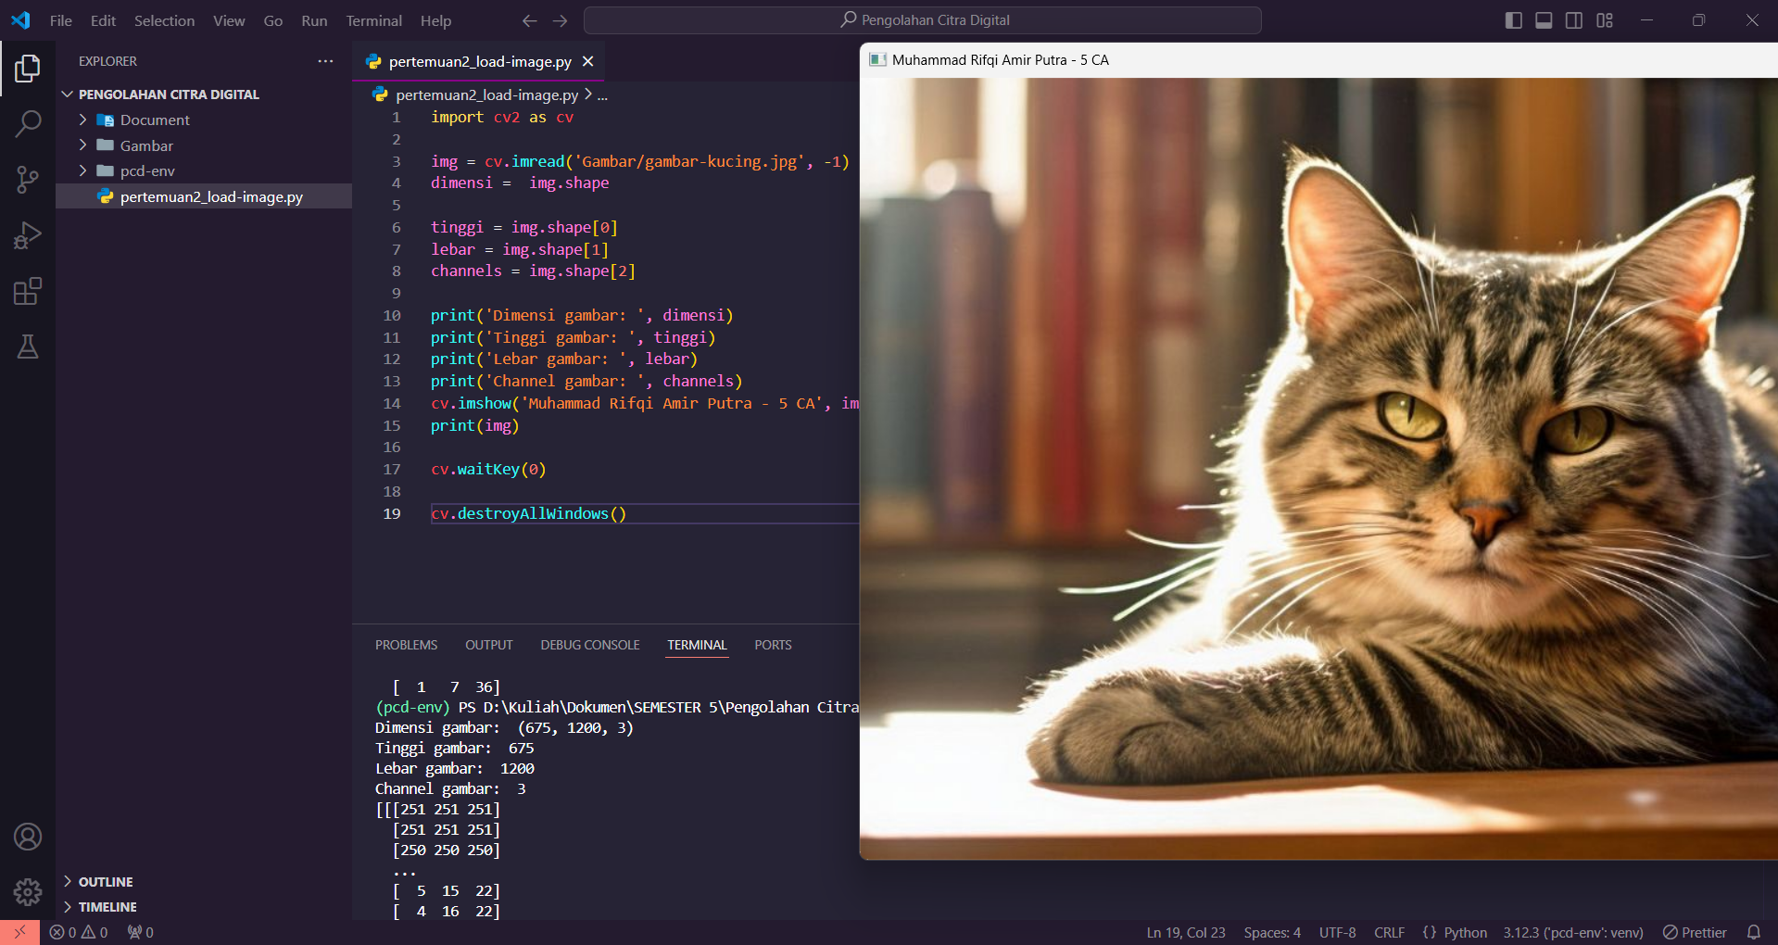

1. **Load Image menggunakan Python di Google Colab**

Source code:

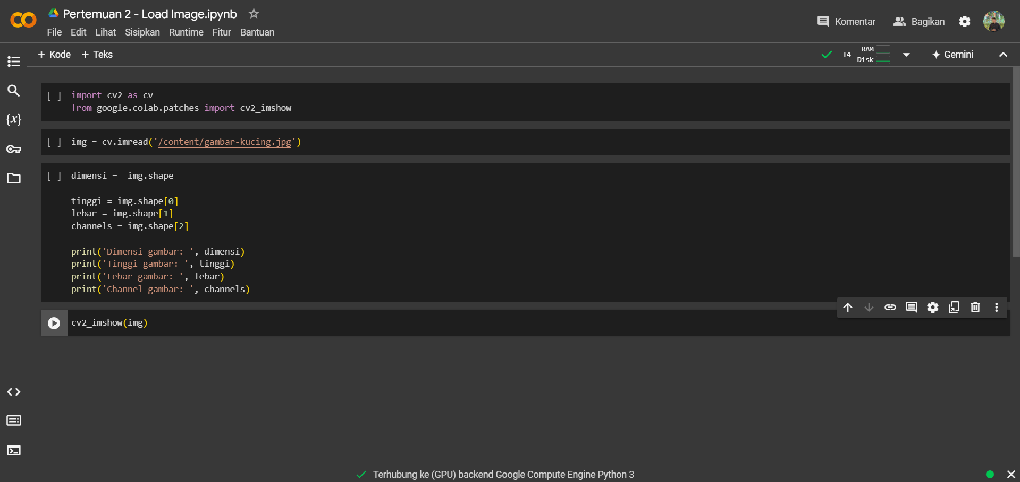

Hasil:

